**The effects of large marine protected areas on industrial fishing effort**

**[Any suggestions that are less dry?]**

Conservation Letters: 3000 words, max 6 figures, max 40 references

TO DO:

* Review documentation of large MPAs. How many aimed to *reduce* fishing effort, and how many aimed to *maintain low effort?* See how many reach/fail that goal
  + Pitcairn = both reduce (“minimize”) and maintain low effort
  + Nazca = can’t find the decree
  + PIPA = can’t find decree, but this link for an overview (<http://www.phoenixislands.org/pdf/AMB-PIPA-2014.pdf>)
  + PMNM = <https://obamawhitehouse.archives.gov/the-press-office/2016/08/26/presidential-proclamation-papahanaumokuakea-marine-national-monument> not explicit though – the focus is on why papa is special, but not much about human threats
  + PRIMNM = <https://obamawhitehouse.archives.gov/the-press-office/2014/09/25/presidential-proclamation-pacific-remote-islands-marine-national-monumen> same as PMNM - doesn’t explicitly highlight fishing reduction
* Review info on which nations sell fishing rights. Is this our best explanation of why effort is high in PIPA but low in Western EEZs?
  + DONE: see Havice 2013. The information on is publically accessible on the WCPFC site, but apparently only through the 8th meeting of the WCPFC (~2010). The more recent data appears unreported (https://www.pnatuna.com/vessel-day-scheme-texts/tae-decisions-and-advisories)
* How many MPAs can we include if we go down to 30,000 km2 instead of 100,00 km2? Davies et al. 2017 uses this (equally arbitrary) cutoff

Target. Conservation Biology Research Note (3000 words): similar to Contributed Papers, but results and inferences may be more focused or preliminary.

**ABSTRACT [150 words]:**

Large marine protected areas (LMPAs) of unprecedented size have recently been established in every ocean, yet their ability to meet conservation objectives is widely debated. Key areas of debate include uncertainty over the intensity of human impacts before and after MPA establishment, the effects of LMPAs on industrial fishing fleets, and nations’ abilities to adequately enforce fishing bans across vast, remote regions. We used a recent vessel tracking platform to quantify the response of industrial fishing effort to 6 LMPAs that were established since 2013. We find that 1) LMPAs successfully keep fishing effort low relative to surrounding regions, but 2) effort was already very low within LMPAs prior to designation. Taken together, our results suggest that LMPAs present conservation opportunities with relatively low political cost, though they typically do not *reduce* fishing effort as initial effort is often negligible in these regions.

**Figures**

**Figure 1. Five large marine protected areas (darker color) and control sites that permit fishing (lighter color) used for comparative analyses. Focal MPAs include: Phoenix Islands Protected Area (red), Papahanaumokuakea National Monument (green), Pitcairn Islands (blue), Pacific Remote Islands (red), and Nazca Desaventuradas (purple).**

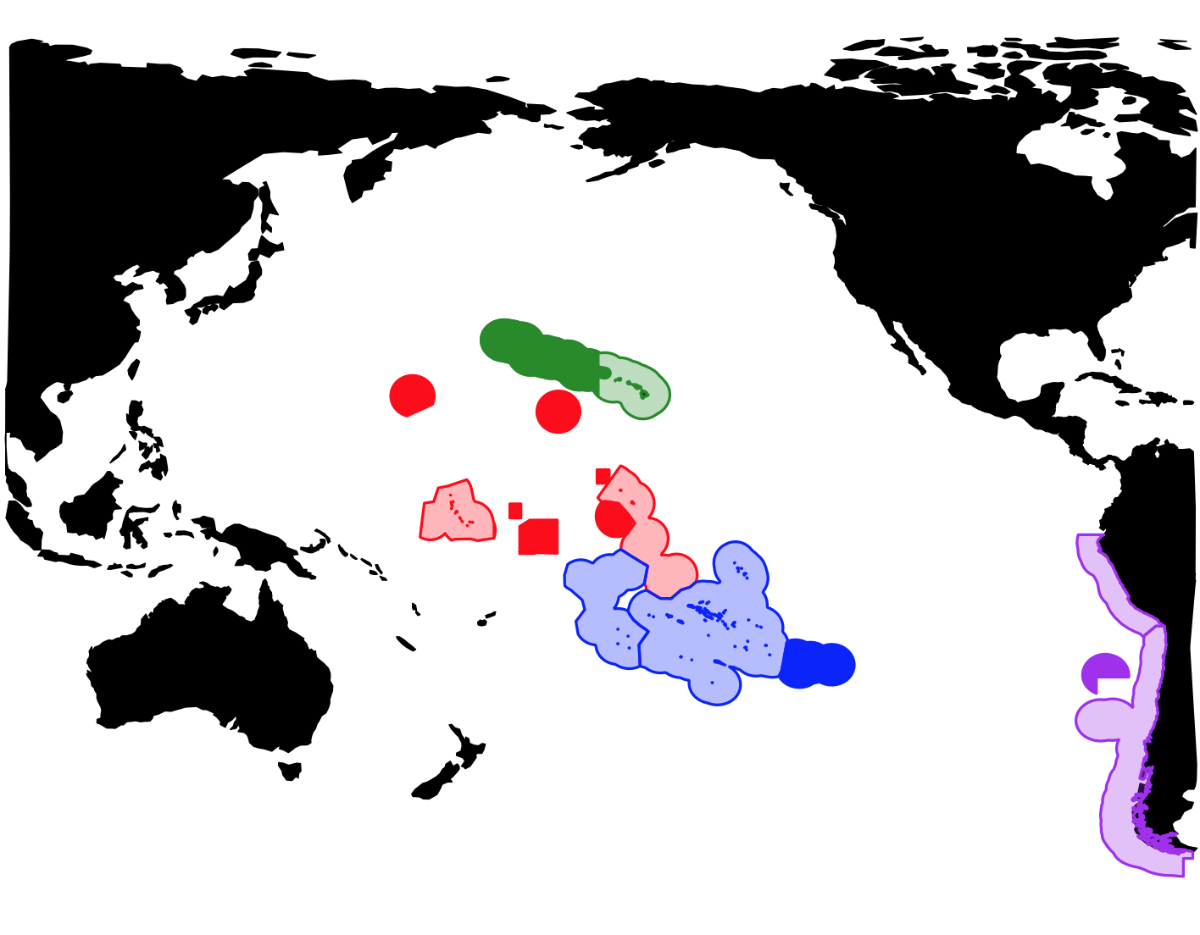

**Figure 2.** Industrial fishing effort for one year before and after five large marine protected areas were established. Maps extend 1 degree beyond MPA boundaries (solid red) or EEZ boundaries (black dashes). Minimal fishing effort is seen in most large MPAs before or after their creation. High rates of fishing observed beyond the boundaries of most large MPAs indicate that industrial fishing vessels are respecting jurisdictional boundaries.

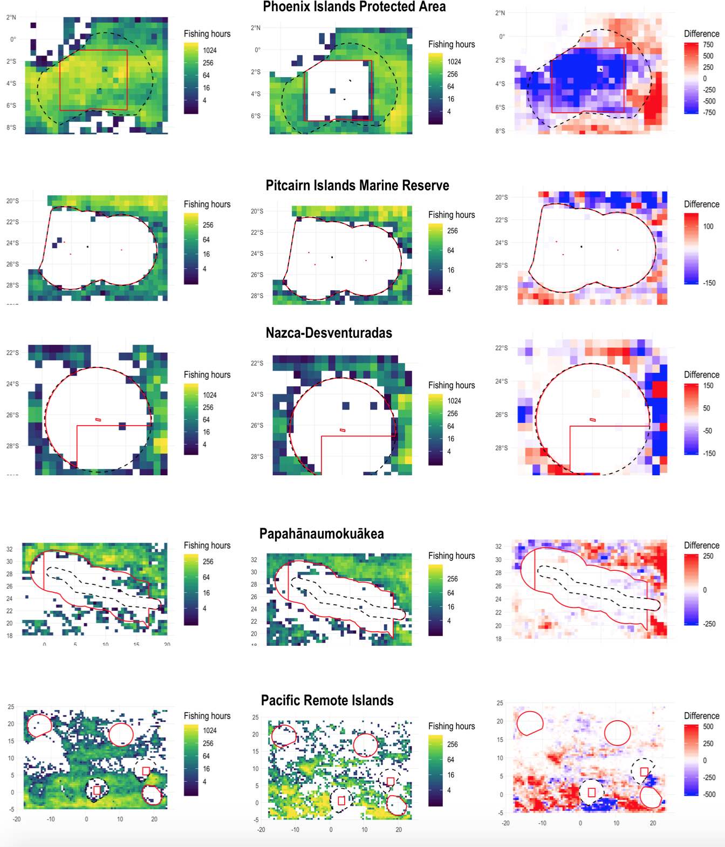

**Figure 3.** Monthly industrial fishing effort detected within large MPAs (black lines) and nearby Exclusive Economic Zones (EEZs) that permit fishing (colored lines). Virtually no fishing is detected within all MPAs after establishment while significant fishing is detected within nearby EEZs, suggesting that differences are due to regulations as opposed to remoteness. Minimal fishing effort is detected in most MPAs prior to establishment; only the Phoenix Islands Protected Area had notable, initial fishing effort.

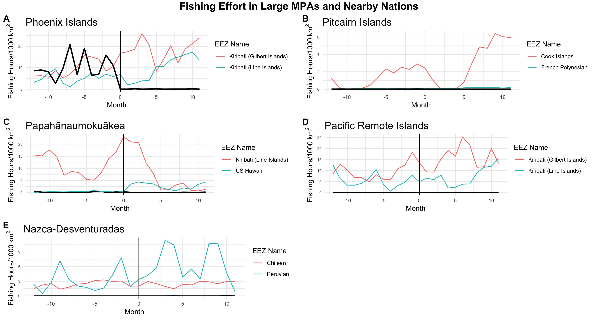

**INTRODUCTION**

More ocean area has been protected in the last decade than in all preceding history (O’Leary et al. 2018). This stark trend is driven by the rising popularity of exceptionally large, marine protected areas (MPAs), which restrict commercial fishing to achieve conservation and/or fisheries goals (Gaines et al. 2010; Wilhelm et al. 2014). MPAs have become widespread over the past several decades, but the super-sizing of MPAs is a very recent occurrence; the mean size of new MPAs has increased tenfold in the last decade, with the largest reserves now topping one million km2 (McCauley et al. 2015).

Many conservationists and researchers have hailed this as meaningful step towards global protection targets (e.g. Aichi Target 11, Boonzaier & Pauly 2016). It has been argued that large MPAs are necessary to protect entire marine ecosystems, which may benefit highly mobile species in ways that smaller MPAs cannot match (White et al. 2017; O’Leary et al. 2018). Large MPAs are often placed at some of the most remote, pristine ecosystems on the planet, thus preserving valuable reference sites for comparison with more degraded regions (Friedlander et al. 2014). The large size of recent MPAs is also thought to bolster their ability to protect the intended species as climate change shifts species distributions (Davies et al. 2017; Roberts et al. 2017).

However, the conservation value of large MPAs has been widely debated within academia, federal governments, and conservation organizations. Key areas of debate include uncertainty over the intensity of human impacts prior to MPA establishment, the effects of large MPAs on industrial fishing fleets, and nations’ abilities to adequately enforce fishing bans across vast, remote regions. Critics of large MPAs often contend that remote zones have minimal fishing effort – even prior to formal designation as a protected area - so resources are misplaced when more immediate threats to biodiversity lie in coastal regions (Devillers et al. 2015; Magris & Pressey 2018; Rocha 2018). The response of industrial vessels to large MPAs is another central point of debate and uncertainty. It has been suggested that the proclamation of large MPAs may actually undermine conservation objectives by attracting increased fishing effort to that region in the time between the MPA is announced and the time that formal protections take effect (McDermott et al. 2018). Additionally, nations’ abilities to adequately enforce fishing bans across vast, remote regions is questioned (De Santo 2013; Leenhardt et al. 2013; Pala 2013; Wilhelm et al. 2014; Jones & De Santo 2016) Federal degazettement, or removal of protections, of large MPAs has received increased momentum as these debates proceed unresolved. For example, U.S. President Donald Trump ordered a review of several large MPAs in U.S. waters to evaluate permitting fishing or other extractive activities in these protected regions (Bruno et al. 2018).

Both supporters and skeptics of large MPAs acknowledge that empirical evidence to evaluate theoretical benefits of protection remain scarce (Kaplan et al. 2013; Friedlander et al. 2016; Ban et al. 2017). Traditional tools of marine ecologists are challenging to implement at the scale that is required to robustly assess the effects of such large MPAs (Kaplan et al. 2013). High resolution data on the catch and effort of commercial fisheries near protected regions can offer powerful insights (Boerder et al. 2017), but these datasets are typically kept private by national governments. Publicly available datasets released by regional fisheries management organizations (RFMOs) are often too coarse (e.g., 5 degree cells) to pinpoint the effects of MPAs.

The recent proliferation of vessel tracking data now allows for direct, empirical investigation of these points of contention. High-resolution tracks of over 70,000 industrial fishing boats have been produced by analyzing detections of vessel Automatic Identification System (AIS) signals – a system originally designed for navigational and safety purposes (Kroodsma et al. 2018). The resulting dataset is comprised of 22 billion detections and captures approximately 50-75% of global fishing effort in offshore regions, where the vast majority of large MPAs are located (O’Leary et al. 2018). This dataset does not capture the activity of small-scale fishing vessels, though subsistence vessels are not the typical target of large MPA regulations (CITE Pitcairn regs). AIS analyses have previously revealed patterns of fishing effort near individual MPAs (McCauley et al. 2016; White et al. 2017; McDermott et al. 2018), but broader views across multiple MPAs are needed to improve understanding of this controversial trend in marine conservation.

Here, we used AIS analysis to investigate points of contention surrounding large MPAs. We processed XX million detections across XXX fishing boats to generate views of commercial fishing before and after the establishment of large MPAs. High resolution data lets us capture trends that may have previously been dulled by aggregate datasets or lack of data. [reiterate specific questions]

**METHODS**

**Study area**

We analyzed fishing effort near all MPAs that fit the following three criteria: 1) no-take protections (all industrial fishing effort prohibited); 2) over 100,000 km2 in size (Friedlander et al. 2016; McCauley et al. 2016; O’Leary et al. 2018), 3) established between January 1, 2013 – January 1, 2018. This date range was chosen to ensure sufficient coverage of our dataset of industrial fishing effort (Kroodsma et al. 2018). These criteria produced five focal MPAs that are located in the Pacific Ocean (Fig 1, Table 1.). We used Protected Planet to retrieve shapefiles for our focal large MPAs.

**Industrial fishing effort**

We mapped satellite detections of industrial fishing vessels to assess their response to newly-established, large MPAs. We accessed the Global Fishing Watch dataset, which uses convolutional neural networks and Automatic Identification System (AIS) detections to identify global fishing effort (Kroodsma et al. 2018). The convolutional neural network uses characteristics of vessel tracks (e.g. speed, course, distance to shore) to identify fishing effort with > 90% accuracy (Kroodsma et al. 2018). The resulting dataset is comprised of 22 billion detections from over 70,000 industrial fishing vessels. Approximately 50-75% of global fishing effort in offshore regions ­– where large MPAs are predominantly located (O’Leary et al. 2018) – is viewable via AIS analysis. The Global Fishing Watch dataset does not capture the activity of small-scale fishing vessels, as may be used by residents but vessels of this nature of often exempted from large MPA regulations (cite Pitcairn).

We analyzed the tracks of all detected fishing vessels that entered a bounding box extending one degree beyond each large MPA boundary. To identify spatial changes in fishing effort following MPA creation, we created aggregate maps of annual fishing effort for one year before and one year after each MPA was established. We calculated the difference in annual fishing hours, defined as the elapsed time between positions identified as fishing (neural net score > 0.5), for each 0.5 by 0.5 degree grid cell. We selected this resolution because longline vessels comprise a majority of fishing effort surrounding large MPAs (e.g., White et al. 2017) and they deploy gear that is approximately 0.5 degrees in length.

In order to “control” for trends in fishing effort that are not driven by protection (e.g., regional oceanography), we compared fishing activity detected in large MPAs and nearby Exclusive Economic Zones (EEZs) that permit industrial fishing Ban, N.C., Davies, T.E., Aguilera, S.E., Brooks, C., Cox, M., Epstein, G., Evans, L.S., Maxwell, S.M. & Nenadovic, M. (2017). Social and ecological effectiveness of large marine protected areas. *Glob. Environ. Change*, 43, 82–91.

Boonzaier, L. & Pauly, D. (2016). Marine protection targets: an updated assessment of global progress. *Oryx*, 50, 27–35.

Davies, T.E., Maxwell, S.M., Kaschner, K., Garilao, C. & Ban, N.C. (2017). Large marine protected areas represent biodiversity now and under climate change. *Sci. Rep.*, 7, 9569.

Friedlander, A.M., Caselle, J.E., Ballesteros, E., Brown, E.K., Turchik, A. & Sala, E. (2014). The Real Bounty: Marine Biodiversity in the Pitcairn Islands. *PLoS ONE*, 9, e100142.

Friedlander, A.M., Wagner, D., Gaymer, C.F., Wilhelm, T. ‘Aulani, Lewis, N., Brooke, S., Kikiloi, K. & Varmer, O. (2016). Co-operation between large-scale MPAs: successful experiences from the Pacific Ocean. *Aquat. Conserv. Mar. Freshw. Ecosyst.*, 26, 126–141.

Gaines, S.D., White, C., Carr, M.H. & Palumbi, S.R. (2010). Designing marine reserve networks for both conservation and fisheries management. *Proc. Natl. Acad. Sci.*, 107, 18286–18293.

Kroodsma, D.A., Mayorga, J., Hochberg, T., Miller, N.A., Boerder, K., Ferretti, F., Wilson, A., Bergman, B., White, T.D., Block, B.A., Woods, P., Sullivan, B., Costello, C. & Worm, B. (2018). Tracking the global footprint of fisheries. *Science*, 359, 904–908.

McCauley, D.J., Pinsky, M.L., Palumbi, S.R., Estes, J.A., Joyce, F.H. & Warner, R.R. (2015). Marine defaunation: Animal loss in the global ocean. *Science*, 347, 1255641.

McCauley, D.J., Woods, P., Sullivan, B., Bergman, B., Jablonicky, C., Roan, A., Hirshfield, M., Boerder, K. & Worm, B. (2016). Ending hide and seek at sea. *Science*, 351, 1148–1150.

McDermott, G.R., Meng, K.C., McDonald, G.G. & Costello, C.J. (2018). The blue paradox: Preemptive overfishing in marine reserves. *Proc. Natl. Acad. Sci.*, 201802862.

O’Leary, B.C., Ban, N.C., Fernandez, M., Friedlander, A.M., García-Borboroglu, P., Golbuu, Y., Guidetti, P., Harris, J.M., Hawkins, J.P., Langlois, T., McCauley, D.J., Pikitch, E.K., Richmond, R.H. & Roberts, C.M. (2018). Addressing Criticisms of Large-Scale Marine Protected Areas. *BioScience*, 68, 359–370.

Roberts, C.M., O’Leary, B.C., McCauley, D.J., Cury, P.M., Duarte, C.M., Lubchenco, J., Pauly, D., Sáenz-Arroyo, A., Sumaila, U.R., Wilson, R.W., Worm, B. & Castilla, J.C. (2017). Marine reserves can mitigate and promote adaptation to climate change. *Proc. Natl. Acad. Sci.*, 114, 6167–6175.

White, T.D., Carlisle, A.B., Kroodsma, D.A., Block, B.A., Casagrandi, R., De Leo, G.A., Gatto, M., Micheli, F. & McCauley, D.J. (2017). Assessing the effectiveness of a large marine protected area for reef shark conservation. *Biol. Conserv.*, 207, 64–71.

Wilhelm, T. ’Aulani, Sheppard, C.R.C., Sheppard, A.L.S., Gaymer, C.F., Parks, J., Wagner, D. & Lewis, N. (2014). Large marine protected areas – advantages and challenges of going big. *Aquat. Conserv. Mar. Freshw. Ecosyst.*, 24, 24–30.

. We selected the nearest two EEZs that permit industrial fishing for each large MPA.

**RESULTS**

Two primary results emerged from our analyses. First, detected fishing effort was exceptionally low in most large MPAs before they ever received formal protection (Fig. 1, 2). For one year prior to MPA designation, these vast expanses of ocean typically only supported 10s or 100s of fishing hours per month. In contrast, we detected up to 30,000 monthly fishing hours in control regions comprised of EEZs that permit fishing (Fig. 2). The Phoenix Islands Protected Area (PIPA) is the only exception to this pattern of low initial fishing effort; up to 15,000 monthly fishing hours were detected within the PIPA’s future boundaries prior to their designation.

Second, we detect virtually no fishing effort in all five large MPAs once they are formally established (Fig. 1.,2). A sharp decline of fishing effort was observed in PIPA, as these waters became essentially unfished once they received protection. Within the other 4 large MPAs, fishing remained at the negligible rates that were detected prior to MPA designation. High levels of fishing effort were generally maintained throughout nearby control regions that did not ban industrial fishing (Fig. 2).

**DISCUSSION**

1. Publicly available vessel tracking data holds the potential to resolve many theoretical uncertainties in marine conservation. We focused this data on large MPAs due to intense debates over their impacts on global fishing fleets. We found two primary results; 1) large mpas are able to effectively maintain effort at remarkably low levels, but 2) regions where MPAs were established were usually unfished prior to their designation as formal protected areas. Our results suggest that most large MPAs do not significantly *reduce* fishing effort; rather, they *maintain* low fishing effort relative to regions that do not receive formal protections.
2. Remote regions are often assumed to have lesser impacts than coastal regions. The low levels of fishing that we see inside large MPAs prior to designation does not appear to be driven by their remoteness, as regions beyond the MPA’s eventual boundaries are heavily fished. Grid cells immediately outside MPA XYZ receive XX times more fishing than grid cells 50 miles outside of California, Hawaii, or New England [NAME more crowded regions]. By comparing effort within MPAs to surrounding EEZs, we see that unprotected EEZs
3. Discuss PNA, Vessel Day Scheme, etc for reasons why Kiribati may stand out from the Western nations (UK, US, etc)
4. Previous investigation at a single large MPA (PIPA) resulted in the conclusion that the announcement of large MPAs may increase fishing effort in that region. We find that the “blue paradox” is a rare phenomenon; in 4 of 5 MPAs considered, effort was consistently low both before and after designation. The increase was only seen in PIPA – the lone MPA considered in McDermott et al. 2018. This result suggests that analysis of multiple large MPAs is necessarys before attempting global extrapolations from one study site. The dynamics reported in McDermott et al. 2018 are likely less widespread than reported. [We caution against globally extrapolations from the dynamics surrounding PIPA (cite McDermott), as it is clear that those dynamics differ greatly from many large MPAs.
5. Discuss philosophy of prioritizing regions immediately threatened vs regions that are easier to protect (less stakeholders). Our results do not resolve this debate, but it brings the facts into focus. Differences in philosophy will still exist, but these differences can be best debated in a data-driven framework.
6. Caveats: Here, we only address fishing, the primary impact targeted by large MPAs regulations. However, large MPAs typically ban other extractive activities including deep sea mining, which is expected to rapidly increase in the coming years. Large MPAs may also protect against climate change (CITE). As fish and fisheries redistribute in a changing climate, large MPAs may prevent shifting impacts from reaching pristine populations. Also: different patterns may emerge in new MPAs, we don’t capture all fishing with AIS, etc.
7. Conclusion: publicly available, high resolution data on extractive activities in our global oceans
   1. Throw shade towards Wilhelm. Large MPA supporters have cast doubt on critics who receive money from “industrial fishing interests,” while these same supporters receive millions from global environmental NGOs. We all have biases, so let’s present the facts.

**REFERENCES**

Ban, N.C., Davies, T.E., Aguilera, S.E., Brooks, C., Cox, M., Epstein, G., Evans, L.S., Maxwell, S.M. & Nenadovic, M. (2017). Social and ecological effectiveness of large marine protected areas. *Glob. Environ. Change*, 43, 82–91.

Boerder, K., Bryndum-Buchholz, A. & Worm, B. (2017). Interactions of tuna fisheries with the Galápagos marine reserve. *Mar. Ecol. Prog. Ser.*, 585, 1–15.

Boonzaier, L. & Pauly, D. (2016). Marine protection targets: an updated assessment of global progress. *Oryx*, 50, 27–35.

Bruno, J.F., Saumweber, W., Crowder, L.B., Pendleton, L., Roady, S.E., Rouleau, T. & Sakashita, M. (2018). Safe Harbors: The Many Benefits of Marine Monuments and Sanctuaries. *Front. Mar. Sci.*, 5.

Davies, T.E., Maxwell, S.M., Kaschner, K., Garilao, C. & Ban, N.C. (2017). Large marine protected areas represent biodiversity now and under climate change. *Sci. Rep.*, 7, 9569.

De Santo, E.M. (2013). Missing marine protected area (MPA) targets: How the push for quantity over quality undermines sustainability and social justice. *J. Environ. Manage.*, 124, 137–146.

Devillers, R., Pressey, R.L., Grech, A., Kittinger, J.N., Edgar, G.J., Ward, T. & Watson, R. (2015). Reinventing residual reserves in the sea: are we favouring ease of establishment over need for protection? *Aquat. Conserv. Mar. Freshw. Ecosyst.*, 25, 480–504.

Friedlander, A.M., Caselle, J.E., Ballesteros, E., Brown, E.K., Turchik, A. & Sala, E. (2014). The Real Bounty: Marine Biodiversity in the Pitcairn Islands. *PLoS ONE*, 9, e100142.

Friedlander, A.M., Wagner, D., Gaymer, C.F., Wilhelm, T. ‘Aulani, Lewis, N., Brooke, S., Kikiloi, K. & Varmer, O. (2016). Co-operation between large-scale MPAs: successful experiences from the Pacific Ocean. *Aquat. Conserv. Mar. Freshw. Ecosyst.*, 26, 126–141.

Gaines, S.D., White, C., Carr, M.H. & Palumbi, S.R. (2010). Designing marine reserve networks for both conservation and fisheries management. *Proc. Natl. Acad. Sci.*, 107, 18286–18293.

Jones, P.J.S. & De Santo, E.M. (2016). Viewpoint – Is the race for remote, very large marine protected areas (VLMPAs) taking us down the wrong track? *Mar. Policy*, 73, 231–234.

Kaplan, D.M., Bach, P., Bonhommeau, S., Chassot, E., Chavance, P., Dagorn, L., Davies, T., Dueri, S., Fletcher, R., Fonteneau, A., Fromentin, J.-M., Gaertner, D., Hampton, J., Hilborn, R., Hobday, A., Kearney, R., Kleiber, P., Lehodey, P., Marsac, F., Maury, O., Mees, C., Ménard, F., Pearce, J. & Sibert, J. (2013). The True Challenge of Giant Marine Reserves. *Science*, 340, 810–811.

Kroodsma, D.A., Mayorga, J., Hochberg, T., Miller, N.A., Boerder, K., Ferretti, F., Wilson, A., Bergman, B., White, T.D., Block, B.A., Woods, P., Sullivan, B., Costello, C. & Worm, B. (2018). Tracking the global footprint of fisheries. *Science*, 359, 904–908.

Leenhardt, P., Cazalet, B., Salvat, B., Claudet, J. & Feral, F. (2013). The rise of large-scale marine protected areas: Conservation or geopolitics? *Ocean Coast. Manag.*, 85, Part A, 112–118.

Magris, R.A. & Pressey, R.L. (2018). Marine protected areas: Just for show? *Science*, 360, 723–724.

McCauley, D.J., Pinsky, M.L., Palumbi, S.R., Estes, J.A., Joyce, F.H. & Warner, R.R. (2015). Marine defaunation: Animal loss in the global ocean. *Science*, 347, 1255641.

McCauley, D.J., Woods, P., Sullivan, B., Bergman, B., Jablonicky, C., Roan, A., Hirshfield, M., Boerder, K. & Worm, B. (2016). Ending hide and seek at sea. *Science*, 351, 1148–1150.

McDermott, G.R., Meng, K.C., McDonald, G.G. & Costello, C.J. (2018). The blue paradox: Preemptive overfishing in marine reserves. *Proc. Natl. Acad. Sci.*, 201802862.

O’Leary, B.C., Ban, N.C., Fernandez, M., Friedlander, A.M., García-Borboroglu, P., Golbuu, Y., Guidetti, P., Harris, J.M., Hawkins, J.P., Langlois, T., McCauley, D.J., Pikitch, E.K., Richmond, R.H. & Roberts, C.M. (2018). Addressing Criticisms of Large-Scale Marine Protected Areas. *BioScience*, 68, 359–370.

Pala, C. (2013). Giant Marine Reserves Pose Vast Challenges. *Science*, 339, 640–641.

Roberts, C.M., O’Leary, B.C., McCauley, D.J., Cury, P.M., Duarte, C.M., Lubchenco, J., Pauly, D., Sáenz-Arroyo, A., Sumaila, U.R., Wilson, R.W., Worm, B. & Castilla, J.C. (2017). Marine reserves can mitigate and promote adaptation to climate change. *Proc. Natl. Acad. Sci.*, 114, 6167–6175.

Rocha, L.A. (2018). Bigger is not better for ocean conservation. *N. Y. Timesaccessed July 2018*.

White, T.D., Carlisle, A.B., Kroodsma, D.A., Block, B.A., Casagrandi, R., De Leo, G.A., Gatto, M., Micheli, F. & McCauley, D.J. (2017). Assessing the effectiveness of a large marine protected area for reef shark conservation. *Biol. Conserv.*, 207, 64–71.

Wilhelm, T. ’Aulani, Sheppard, C.R.C., Sheppard, A.L.S., Gaymer, C.F., Parks, J., Wagner, D. & Lewis, N. (2014). Large marine protected areas – advantages and challenges of going big. *Aquat. Conserv. Mar. Freshw. Ecosyst.*, 24, 24–30.

**SUPPLEMENTARY MATERIALS**

**Figure of all 6 MPAs 1 year before and after no-take implementation, not area controlled (1/20)**

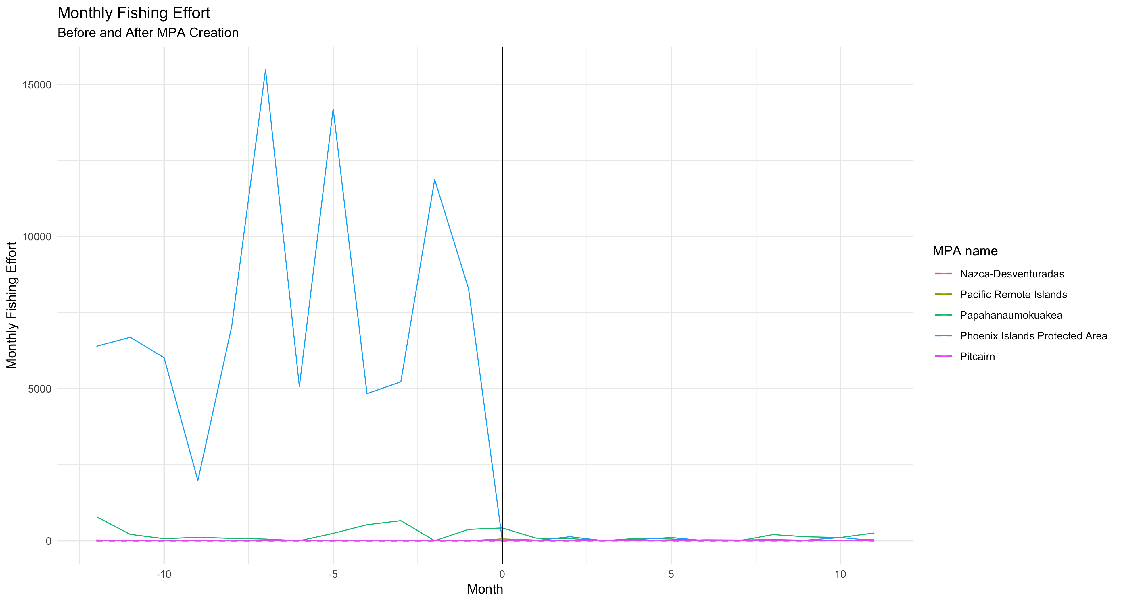

**Figure of trends before area correction (1/20)**

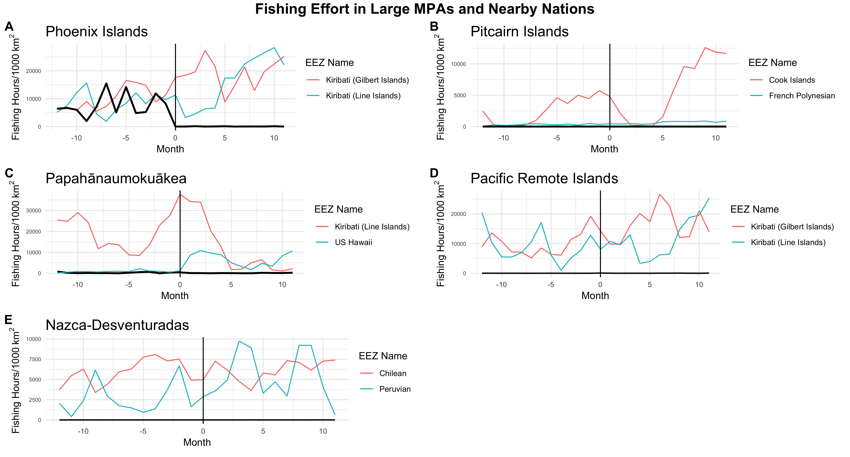

**Shark Sanctuary fishing effort 1/14-1/18 (1/20)**

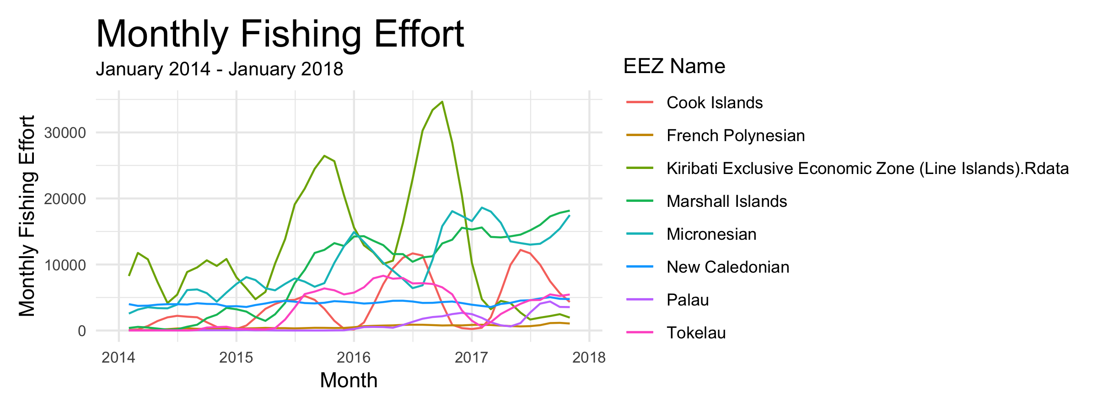

References:

* Large MPAs are tough to enforce (De Santo 2013, Leenhardt et al. 2013, Wilhelm et al. 2014, Pala 2013, Jones and De Santo 2016)
* Remote zones have little human impacts so we should protect them (Nelson and Bradner 2010, Singleton and Roberts 2014, Toonen et al. 2013, Wilhelm et al. 2014, O’Leary 2018, Pala 2013). Gross 2018 alludes to low impacts in remote zones
* Large MPAs will not reduce catch but merely displace effort by moving boats around (Wilhelm et al. 2014)
* Remote zones have little impacts so we should *not* protect them (Devillers 2014, Magris and Pressey 2018)
* Large MPAs help *reduce* fishing (Pala 2013, Toonen et al. 2013)
* Large MPAs are in remote regions to buffer against future declines (O’Leary 2018)
* Contrary to common perception, large MPAs actually are subject to high levels of human impact (Davies et al. 2017). Large MPAs attract increases in fishing effort that lead to overfishing prior in between MPA announcement and legal creation (McDermott et al. 2018).
* Aichi Target 10 is to *minimize* impacts of vulnerable ecosystems. Most large MPAs established in recent years do not fulfill this goal as impacts are beneficially locked in at already-low levels, though they are not *reduced*.
  + Target 11 is to protect 20% - this one will be helped by large MPAs (Toonen et al. 2013)

To cite:

* O’Leary et al. 2018 – percent of ocean in MPAs, common criticisms of large MPAs
* Gross 2018 (Current Biology) news piece about the promise of new tech for monitoring MPAs, implies that Pitcairn has low effort because it’s remote so we can cite this
* Havice 2013 - good overview of Nauru Agreement, which describes the sale of fishing rights to other nations. Also mention US Tuna Treaty which is how US buys Pacific fishing rights (as opposed to selling them). This may partially explain patterns of low effort in developed/Western EEZs of the tropical Pacific.